Project Documentation

Rhythmic Tunes

# Introduction

## Project Title: Rhythmic Tunes

* + **Team ID:** NM2025TMID47738
  + **Team Leader:** Nisha.S & [nishas20071@gmail.com](mailto:nishas20071@gmail.com)

## Team Members:

- Nithiya.M & [mnithiya418@gmail.com](mailto:mnithiya418@gmail.com)

- Pavithra.V & [pavinithi2505@gmail.com](mailto:pavinithi2505@gmail.com)

- Pravanya Devi.N & [pravanya253@gmail.com](mailto:pravanya253@gmail.com)

# Project Overview

* + **Purpose:** Rhythmic tunes serve multiple purposes across different contexts—biological, psychological, cultural, and social.

## Features:

* + - 1. **Strong, Steady Beat**
    - 2. **Syncopation**
    - 3. **Repetition**
    - 4. **Groove and Feel**

# Architecture

**Frontend: Tech Stack:**

* React.js / Vue.js / Svelte
* HTML5 + CSS3 (or TailwindCSS)
* Web Audio API or Tone.js (for sound synthesis and playback)

**Backend: Tech Stack:**

* Node.js / Express.js (or Python Flask/Django, or Go)
* Socket.IO (for real-time collaboration or live playback sync)
* REST or GraphQL API

**Database: Tech Stack:**

* MongoDB (NoSQL) for flexibility in rhythm pattern structures
* OR PostgreSQL (SQL) for structured user/project relationships
* Redis (for caching and real-time sessions)

# Setup Instructions

## Prerequisites:

* + - Node.js and npm:
    - React.js
    - Create a new React app
    - Running the React App:

## Installation Steps:

• **Prerequisites**

* Install Node.js (recommend version >= 14 or whatever the project requires)
* Install npm or yarn
* (Optional) Git, if you are cloning from a repository

• **Clone / Get the Source Code**

git clone <repository‑URL>

cd RhythmicTunes

• **Install Dependencies**  
In the project directory:

npm install

# Folder Structure

rhythmic-tunes/

│

├── public/ # Static files like index.html, images, favicon

│ └── index.html

│

├── src/ # Source code

│ ├── components/ # Reusable UI components (Player, Navbar, etc.)

│ ├── pages/ # Main pages or views (Home, Playlist, Profile)

│ ├── services/ # API calls and backend communication

│ ├── App.js # Main app component

│ ├── index.js # Entry point to render the app

│ └── styles.css # Global styles

│

├── .gitignore

├── package.json

└── README.md

# Running the Application

### Frontend:

* **Node.js** installed (recommended v16+): nodejs.org
* **npm** (comes with Node.js) or **yarn** (optional)

### 2. ****Get the Frontend Code****

* If you haven’t already, clone or download the frontend code:

git clone <repo-url>

cd rhythmic-tunes/frontend

## Backend:

### 1. ****Prerequisites****

* **Node.js** installed (recommended v16+) — https://nodejs.org/
* **npm** or **yarn**

### 2. ****Get the Backend Code****

If you don’t have it locally yet, clone the repo and navigate to backend folder:

git clone <repo-url>

cd rhythmic-tunes/backend

* + **Access:** Visit [http://localhost:3000](http://localhost:3000/)

# API Documentation

## User:

* + - /api/v1/users/register
  + [Nishas20071@gmail.com](mailto:Nishas20071@gmail.com)

## Projects:

**1. Setup React Application:**

• Create React application.

• Configure Routing.

• Install required libraries.

Setting Up Routes:-

# Authentication

Authentication ensures only authorized users can access and manage their rhythmic tunes and profiles. We use token-based authentication with JWT (JSON Web Tokens).

# User Interface

* + Landing Page
  + Freelancer Dashboard
  + Admin Panel
  + Project Details Page

# Testing

* + Manual testing during milestones
  + Tools: Postman, Chrome Dev Tools

1. **Screenshots or Demo**

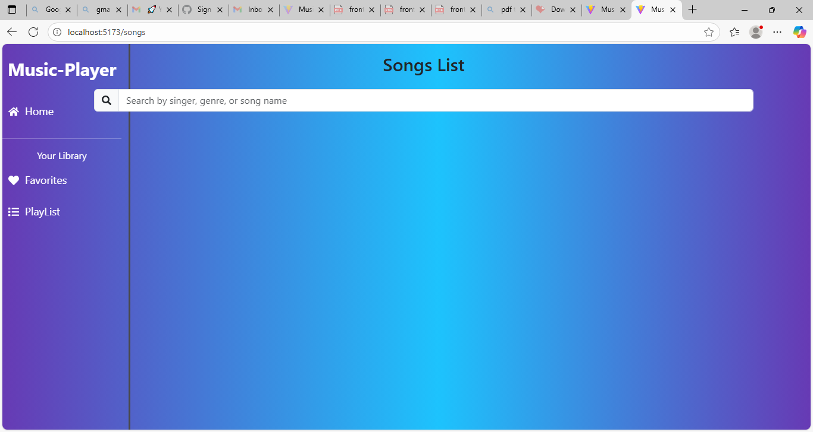

1. **Future Enhancements**

1. **Real-Time Collaborative Jamming**